

REACT JS PROJECT REPORT ON
STUDENT PERFORMANCE ANALYTICS

Submitted by
Lavanya S
24BIT026

Under the Guidance of
Aravind
Technical Trainer
Technical Department, KG College of Arts and Science

Academic Year: 2025 – 2026
APRIL 2026

DECLARATION
I hereby declare that the project entitled “STUDENT PERFORMANCE ANALYTICS” submitted in partial fulfillment of the requirements for the course React Js is a record of my original work carried out under the guidance of Aravind Technical Trainer, Technical Department, KG College of Arts and Science.
I further declare that this project has not been submitted previously, either in part or in full, for the award of any degree, diploma, or other similar title, at this or any other institution.
I have acknowledged all sources of information used in this project wherever applicable.

April 2026
Coimbatore

Lavanya S ________________________

CERTIFICATE
This is to certify that the project entitled “STUDENT PERFORMANCE ANALYTICS” is a bona fide work carried out by Lavanya S, II year, B.Sc Information Technology, KG College of Arts & Science, in partial fulfillment of the requirements for the course React Js.
This project has been completed under my supervision and guidance during the academic period April 2026.

Place: KG College of Arts and Science
Date:09/04/2026

Submitted for the Viva-Voce Examination held on ___________09/04/2026_____________

Guide: Head of the Department
(Technical Trainer, KGCAS) (Technical Head, KGCAS)

______________________ _______________________

TABLE OF CONTENTS
S. No. | Topics | Page. No.
1 | Introduction
1.1 | Background of the Study
1.2 | Problem Statement
1.3 | Objectives of the Project
1.4 | Purpose and Significance
1.5 | Scope and Limitations
1.6 | Methodology Overview
2 | System Analysis
2.1 | Existing System
2.2 | Drawbacks of the Existing System
2.3 | Proposed System
2.4 | Features of the Proposed System
2.5 | Feasibility Study
2.6 | Requirement Analysis
3 | System Design
3.1 | System Architecture
3.2 | Use Case Diagram
3.3 | Data Flow Diagram (DFD)
3.4 | Entity Relationship Diagram (ERD)
3.5 | User Interface Design
4 | System Implementation
4.1 | Development Tools
4.2 | Module Description
4.3 | Algorithms
4.4 | System Integration
4.5 | Security and Validation
5 | System Testing
5.1 | Testing Methodology
5.2 | Test Cases
5.3 | Error Handling
5.4 | Performance
6 | Input and Output Screens
6.1 | System Outputs
6.2 | Discussion
6.3 | Comparison
6.4 | User Feedback
7 | Conclusion and Future Enhancement
7.1 | Summary
7.2 | Limitations
7.3 | Future Scope
8 | References
Appendices
- Source Code Snippets
- Screenshots of Web Pages

ABSTRACT
The Student Performance Analytics System is a web-based application developed using React JS that helps analyze and visualize student academic performance. The system allows users to view student data, filter results, and generate insights through interactive charts and dashboards.
The main objective of this project is to simplify the process of monitoring student progress by providing real-time analytics such as marks distribution, subject-wise performance, and overall trends. The application uses modern frontend technologies like React JS, Axios, and Recharts to deliver a dynamic and responsive user experience.
This system helps educators and students identify strengths and weaknesses, enabling better academic decisions. It can be further enhanced by integrating backend services, authentication, and predictive analytics.

Chapter 1: Introduction
1.1 Background of the Study
In today’s digital world, analyzing student performance manually is time-consuming and inefficient. Educational institutions require automated systems to track and evaluate student data effectively. Student Performance Analytics provides insights using data visualization tools, making analysis faster and more accurate.
1.2 Problem Statement
Traditional methods of evaluating student performance rely on manual calculations and static reports. These methods:
- Lack real-time insights
- Are time-consuming
- Do not provide visual representation
Hence, a dynamic system is required to analyze and display student performance efficiently.
1.3 Objectives of the Project
- To develop a React JS-based analytics dashboard
- To visualize student performance using charts
- To filter and analyze student data dynamically
- To improve decision-making through data insights
1.4 Purpose and Significance of the Study
This project helps:
- Teachers analyze student progress easily
- Students understand their performance
- Institutions make data-driven decisions
1.5 Scope and Limitations
Scope:
- Displays student marks and analytics
- Interactive charts and filters
- Dashboard-based visualization
Limitations:
- No backend/database (static/mock API)
- No login system
- Limited dataset

1.6 Methodology Overview
The project follows SDLC:
- Requirement Analysis
- System Design
- Development using React JS
- Testing
- Deployment

Chapter 2: System Analysis
2.1 Existing System
- Manual result analysis
- Static Excel reports
- No visualization
2.2 Drawbacks of the Existing System
- Time-consuming
- Error-prone
- No real-time insights
2.3 Proposed System
A React-based dashboard that:
- Fetches student data via API
- Displays charts (Bar, Pie)
- Allows filtering
2.4 Features of the Proposed System
- Interactive dashboard
- Real-time filtering
- Data visualization (charts)
- Responsive UI
2.5 Feasibility Study
Technical Feasibility:
The system is developed using modern technologies like React JS, Axios, and Recharts, which are easy to implement and widely supported. These tools ensure fast development, good performance, and compatibility across different platforms.
Economic Feasibility:
The project is cost-effective as it uses free and open-source tools. No additional hardware or licensed software is required, making the development and deployment inexpensive.
Operational Feasibility:
The system is user-friendly and easy to operate. It provides an interactive dashboard for analyzing student performance with minimal training. The application is accessible through web browsers, reducing manual effort and improving efficiency.
2.6 Requirement Analysis
Functional Requirements:
- View student data
- Filter results
- View analytics charts

Non-Functional Requirements:
- Fast performance
- Responsive design
- Scalability

Chapter 3: System Design
3.1 Introduction
3-Layer Architecture:
- Frontend (React JS)
- Logic Layer (JS functions)
- Data Layer (API/JSON)
3.2 System Architecture
The system follows a three-layer architecture — Presentation Layer (Frontend), Application Logic Layer, and Data Layer to efficiently manage student data and analytics.
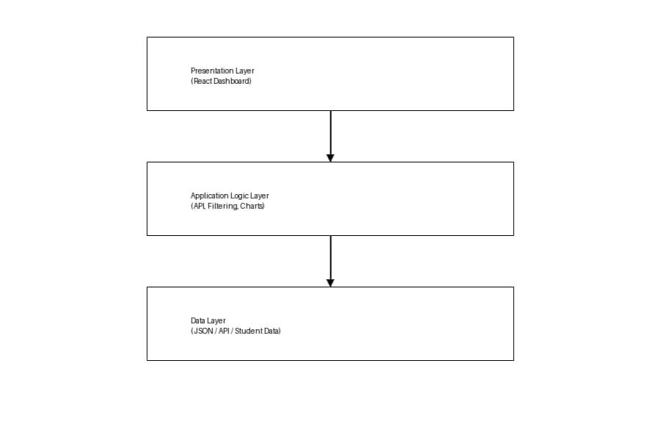
Description:
- Handles user interaction and displays dashboards, charts, and student data.
- Processes data, applies filters, and performs calculations for analytics.
- Stores student information such as marks, subjects, and performance records.
3.3 Use Case Diagram
1. What is a Use Case Diagram?
A Use Case Diagram visually represents how users interact with the Student Performance Analytics System. It shows:
- Actors → users interacting with the system (Student, Admin)
- Use Cases → actions like viewing performance, filtering data, and analyzing results
- Relationships → how these actions are connected
It helps to clearly explain “who performs what action” in the system.
2. Identify the Main Actors (for your Educational Website)
Actor | Description
Student/User | Views performance data, checks marks, and analyzes results through charts.
Administrator (optional) | Manages student data, updates marks, and maintains system data.
Guest/Visitor (optional) | Can view limited analytics without full access.

3. Identify the Main Use Cases
For Student/User
- View Dashboard
- View Student Performance
- Filter Data (by subject, marks, etc.)
- View Charts and Analytics
- Compare Performance
- View Overall Results
For Administrator:
- Login to System
- Add Student Data
- Update Marks
- Delete Student Records
- Manage Performance Data
4. Define Relationships
Symbol | Meaning
Solid line | Association (Actor interacts with system)
<> | A mandatory sub - process
<> | An optional process
Example:
- Attempt Quiz” <<include>> “Submit Quiz”
- “View Result” <<extend>> “Attempt Quiz”

5. Draw the Diagram (Structure Example)
Tools you can use:
- Draw.io (recommended)
- Lucidchart
- StarUML
- MS Visio
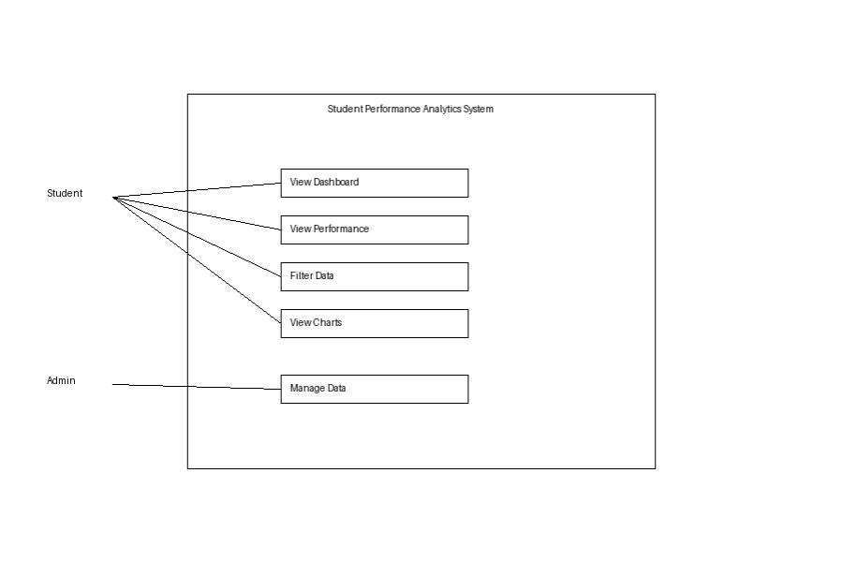
DFD for Educational Website
Level 0: Context Diagram
Student/Admin → [Student Performance Analytics System] → Results/Reports
Explanation:
  - Student interacts with the system to view courses, read lessons, and take quizzes.

  - Admin updates and manages course and quiz content.

Level 1: Detailed System View
Explanation:
Student → View Dashboard → Fetch Data → Display Charts
Admin → Manage Data → Update Dataset
- Process P1: Fetches students data
- Process P2: Filter Data
- Process P3: Generates Chart
- Process P4: Displays result

3.4 Entity Relationship Diagram (ERD)
Entities and Relationships:
- Student (ID, Name, Marks)
- Subject (Subject_ID, Name)
- Performance (Marks, Grade)
Relationships:
- Student → has → Performance
- Subject → linked to → Performance
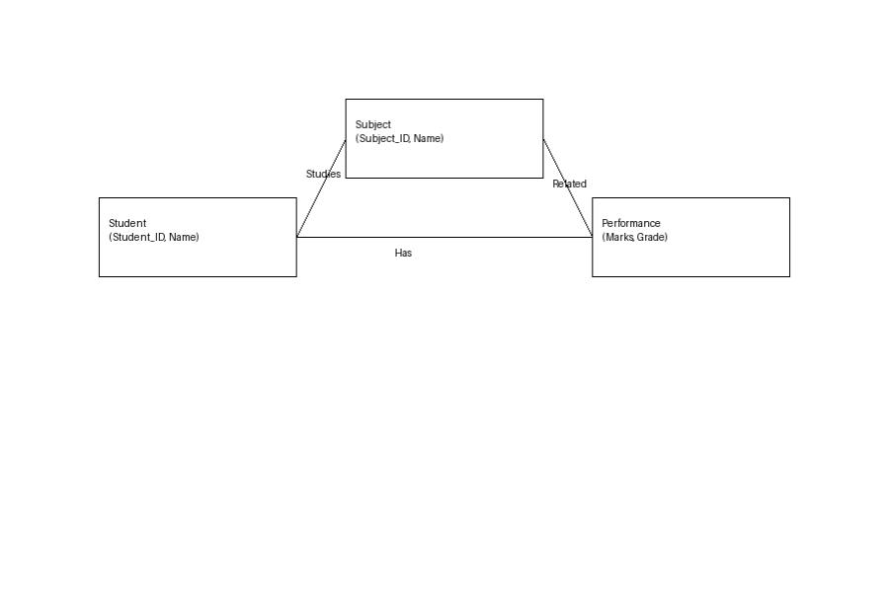
3.5 User Interface Design

Pages:
- Dashboard
- Filter Panel
- Charts Section
- Student Table

Chapter 4: System Implementation
4.1 Introduction
System implementation is the phase where the design is converted into a working web application. It involves coding, integrating modules, testing functionalities, and ensuring smooth performance. The Student Performance Analytics System is implemented using React JS and related technologies to provide an interactive and responsive dashboard. The system allows users to analyze student data, visualize performance, and generate insights effectively.
4.2 Development Tools and Technologies
Tool / Technology | Purpose
React JS | Builds dynamic and responsive user interface
Axios | Fetches student data from API
Recharts | Displays charts and data visualization
JavaScript (ES6) | Handles logic and interactivity
Visual Studio Code | Code editor for development
Browser (Chrome / Edge) | Execution and debugging
JSON/API | Stores and retrieves student data

4.3 System Modules Description
Module | Description
Dashboard module | Displays overall student performance analytics
Filter module | Allows filtering by marks, subjects, or categories
Chart module | Visualizes data using bar charts and pie charts
Student table module | Displays detailed student records
Data management module | Handles fetching and updating student data
Each module is interconnected through JavaScript functions, ensuring smooth navigation and state management within the website.

4.4 Implementation Details
The implementation follows a modular approach:
- Frontend Design:
The user interface is developed using React JS with components for dashboard, charts, and tables.
- Dynamic Behavior:
React state and props are used to dynamically update UI based on user interaction and data changes.
- Event Handling:
User actions such as filtering and selecting data are handled using event listeners like onClick and onChange.
- Quiz Evaluation Logic:
Student data is processed to calculate averages, performance metrics, and generate visual insights.
- Data Management:
Data is fetched from APIs or JSON files and stored temporarily

4.5 Algorithm / Logic of Core Function
Algorithm for Quiz Evaluation:
- Fetch student data from API/JSON.
- Apply filters based on user selection.
- Calculate metrics (average marks, subject-wise performance).
- Generate charts using processed data
- Display results on dashboard.

Algorithm for Dynamic Lesson Display:
- Receive filter input from user
- Compare filter criteria with student data.
- Extract matching records.
- Update state with filtered data.
- Refresh UI with new results.

4.6 Security and Validation
- Input validation ensures correct filtering inputs.
- Invalid or empty data is handled properly.
- Data is stored locally without exposing sensitive information.
- Error handling is implemented using conditional checks and alerts.

4.7 Integration
All components are integrated using React architecture. Data flows between components using props and state. API integration ensures real-time data updates. The system provides smooth navigation without page reloads.
4.8 Output Screens (Snapshots)
Include labelled screenshots for:
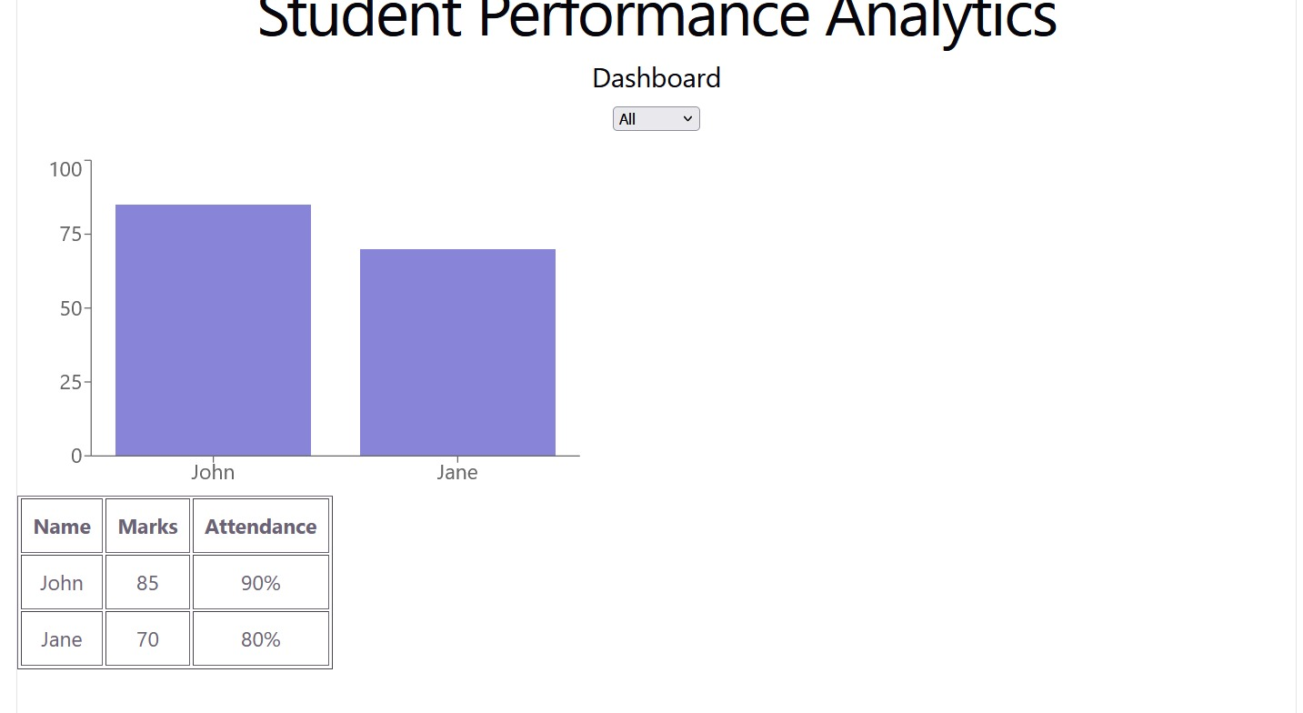

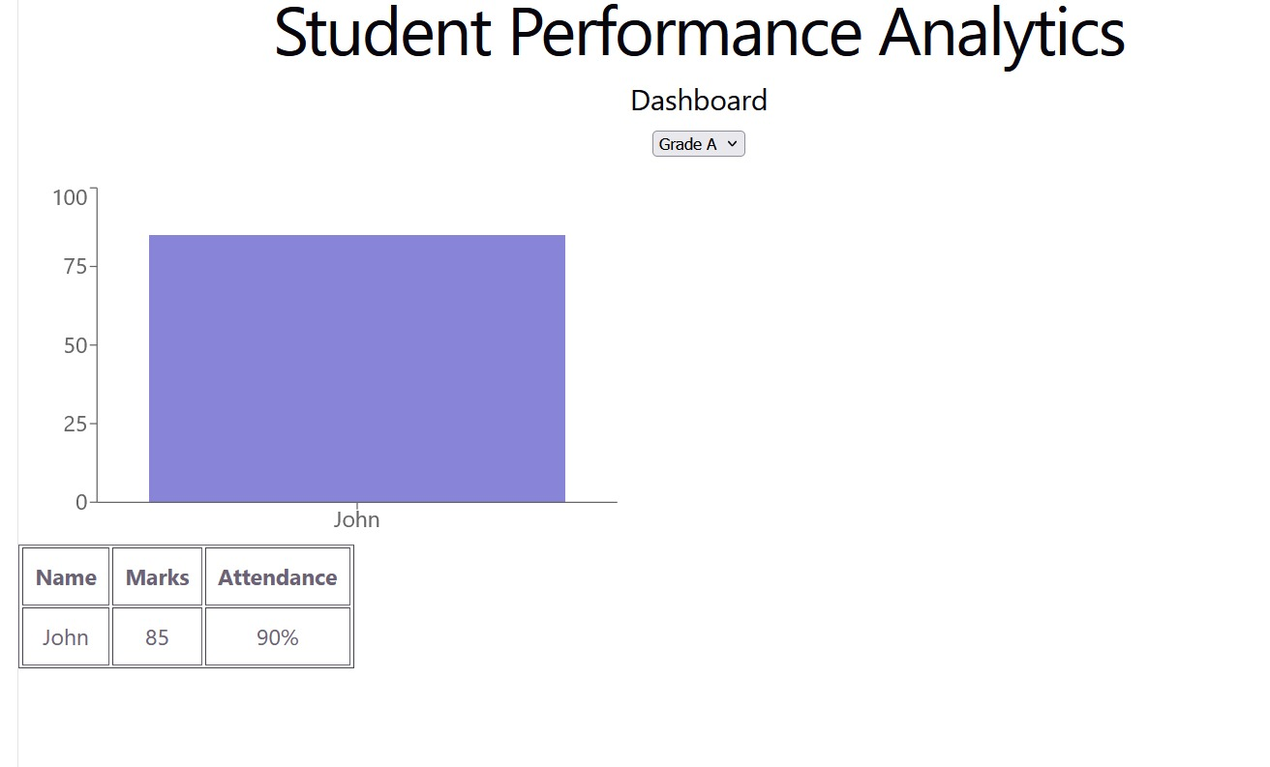
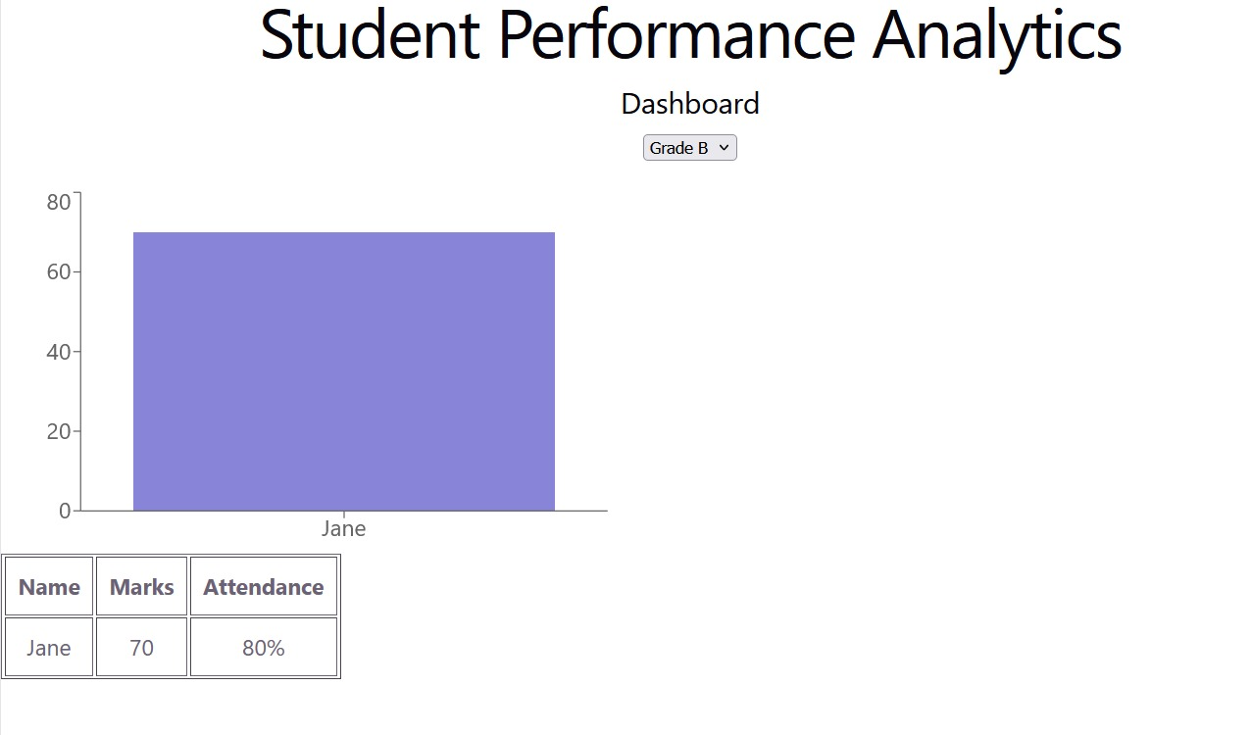

Chapter 5: System Testing
  - Introduction
System testing ensures that the Student Performance Analytics application meets all functional and non-functional requirements. It verifies whether the system works correctly under different conditions. Testing was conducted to validate modules such as dashboard display, data filtering, chart visualization, and performance analysis. The goal is to ensure the system is reliable, accurate, and user-friendly.

5.2 Objectives of Testing
- To ensure all modules (Dashboard, Filter, Charts, Table) function correctly
- To identify and fix errors in data processing and visualization
- To verify correct output for given student data
- To ensure smooth performance across browsers and devices
5.3 Types of Testing Performed
a) Unit Testing
Each component and function (such as data fetching, filtering logic, and chart rendering) was tested individually to ensure correct functionality
b) Integration Testing
All modules were combined and tested together to ensure smooth data flow between dashboard, filters, charts, and tables.
c) System Testing
The entire application was tested to ensure it meets all requirements, including data visualization, performance calculation, and responsiveness.
d) User Acceptance Testing (UAT)
The system was tested by users to check usability, interface design, and performance. Feedback was collected and improvements were made.
e) Cross-Browser and Device Testing
The application was tested on browsers like Chrome, Edge, and Firefox, and on devices such as mobile phones and laptops to ensure responsiveness.
5.4 Test Plan
Test ID | Module | Test Description | Type | Expected Output | Status
T01 | Dashboard | Display student data | Functional | Data visible correctly | Pass
T02 | Filter | Apply filter options | Functional | Filtered data shown | Pass
T03 | Chart | Display performance charts | UI | Correct  graphics displayed | Pass
T04 | Table | Show student records | Output | Accurate data is displayed | Pass
T05 | Navigation | Move between components | Integration | Smooth transition | Pass
T06 | Input Validation | Apply empty filter | Validation | Error message shown | Pass
T07 | Responsiveness | View on mobile | UI | Layout adjusts to screen size | Pass
T08 | Data Loading | Fetch API data | Data | Data is successfully loaded | Pass

5.5 Test Data and Execution
Sample student data was created in JSON format. The system fetched and displayed data dynamically using Axios. Outputs were verified by comparing expected results with actual results shown in charts and tables.
5.6 Error Handling
- Input validation ensures valid filter selections
- API errors are handled using error messages
- Invalid or empty data is handled properly
- Alerts and conditions guide users during errors
5.7 Performance and Usability Testing
Performance: Fast loading and quick data processing
Usability: Easy to use dashboard and navigation
Accessibility: Clear layout and readable design
5.8 Results and Observations
All modules worked correctly and produced accurate results. The system performed efficiently on different devices and browsers. Users found the system easy to use and helpful for analyzing student performance. No major errors were found during testing.

Chapter 6: Results and Discussion
6.1 Introduction
This chapter presents the results obtained after implementing and testing the Student Performance Analytics System. It explains how each module performed during execution and evaluates how effectively the system achieved its objectives. The system was tested for accuracy, usability, and performance in analyzing student data.
6.2 System Output
During execution, the system produced the following key results:
- Dashboard: Displayed overall student performance with summary statistics and insights.
- Filter Section: Allowed users to filter student data based on marks, subjects, or categories dynamically.
- Charts Section: Displayed visual representations such as bar charts and pie charts for performance analysis.
- Student Table: Showed detailed student records including marks, subjects, and performance status.
All components were responsive and worked efficiently across desktop and mobile devices.
6.3 Performance Analysis
- Responsiveness: The system loads quickly and updates data instantly.
- Accuracy: Performance calculations and analytics results are accurate.
- Stability: No major errors or crashes during repeated testing.
- Cross-Browser Compatibility: Works smoothly on Chrome, Edge, and Firefox.
6.4 User Feedback
A group of users tested the system and provided feedback:
- Easy to understand dashboard and navigation
- Clear and effective data visualization
- Helpful for analyzing student performance quickly
- Suggested adding login system and advanced analytics features

Chapter 7: Conclusion and Future Enhancement
7.1 Conclusion
The Student Performance Analytics System successfully demonstrates how modern web technologies can be used to analyze and visualize student data effectively. Using React JS and related tools, the system provides an interactive dashboard that helps users understand performance through charts and tables.
The project achieved its main objectives by delivering a user-friendly and responsive application. All modules, including data display, filtering, and visualization, worked efficiently and accurately. The system meets key requirements such as usability, performance, and accessibility.
This project shows how data visualization can improve decision-making in education and serves as a strong base for developing advanced analytics systems in the future.

7.2 Limitations
While the system performs well, it has some limitations:
- No user authentication or login system
- Uses static data (JSON/API) instead of a full database
- Limited dataset for analysis
- No advanced analytics or prediction features
7.3 Future Enhancement

The system can be improved with the following features:
- Database Integration:
Connect with databases like MySQL or MongoDB for real-time data storage.
- User Authentication:
Implement login and registration for secure access.
- Admin Panel:
Allow admins to manage student data dynamically.
- Advanced Analytics:
Add AI-based prediction of student performance.
- Data Visualization Enhancements:
Include more advanced charts and reports.
- Cloud Deployment:
Host the system online using platforms like AWS or Firebase.
- Accessibility Improvements:
Improve usability with better UI and multi-device support.

Chapter 8: References
  - Books & Journals
1.Web Technologies: HTML, CSS, JavaScript, PHP, Java, JSP, XML, and AJAX — Uttam K. Roy, Oxford University Press.
2.Learning Web Design — Jennifer Niederst Robbins, O’Reilly Media.
3.Data Analytics for Beginners — John Paul Mueller & Luca Massaron, Wiley.
4.Practical Data Analysis — Hector Cuesta, Packt Publishing.
8.2 Online Resources
- MDN Web Docs — https://developer.mozilla.org⁠�
- W3Schools — https://www.w3schools.com⁠�
- React Official Documentation — https://react.dev⁠�
- Recharts Documentation — https://recharts.org⁠�
- Axios Documentation — https://axios-http.com⁠�
- GeeksforGeeks — https://www.geeksforgeeks.org⁠�

8.3 Tools & Frameworks Used
Editor: Visual Studio Code
- Languages: JavaScript (ES6), HTML5, CSS3
- Framework/Library: React JS, Recharts
- API Tool: Axios
- Database (Future Scope): JSON / MongoDB / MySQL
- Browser: Google Chrome / Microsoft Edge

Appendices
Appendix A – Source Code
Include :
- App.js / Dashboard.jsx — Main dashboard structure and layout
- AnalyticsChart.jsx — Displays charts and performance graphs
- FilterPanel.jsx — Handles filtering of student data
- StudentTable.jsx — Displays student records in table format
- api.js — Handles API calls using Axios
AppendixB-ScreenshotsofWebPages





Appendix C – User Manual / Installation Guide
Steps to Run the Project:
- Download or clone the project folder
- Open terminal in the project directory
- Run npm install to install dependencies
- Run npm start to start the application
- Open browser and visit http://localhost:3000
- View dashboard, apply filters, and analyze student performance
System Requirements:
- OS: Windows / macOS / Linux
- Browser: Latest Chrome or Firefox
- RAM: Minimum 4 GB
- Storage: 200 MB free

